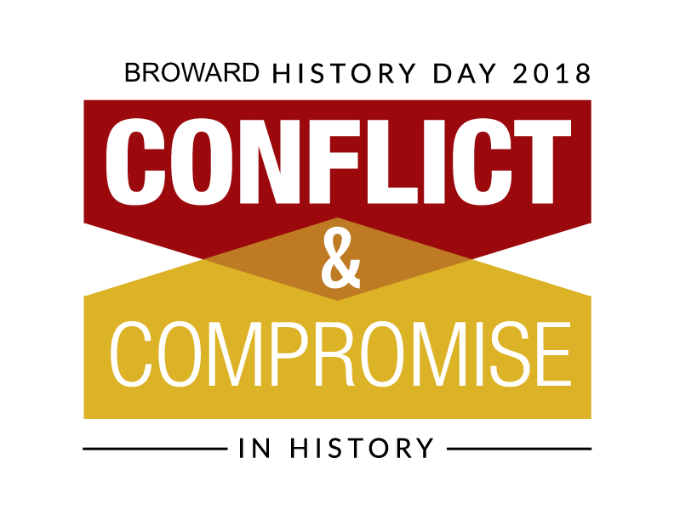

Group Contract

(maximum of five students)

Name: __________________________________________________________________

General topic: ___________________________________________________________

Area of emphasis: ________________________________________________________

Date project is due: _______________________________________________________

Students who wish to work in groups must have the contract signed by all students and parents/guardians involved. Once formed, the group will receive a blanket grade for the project. No allowances will be made if one member does not participate fully. Choose your group carefully.

The group agrees to share equally in all work and in all expenses. Money may not be spent unless all members are consulted. All prize monies will be split evenly among the students.

We agree to work together to complete our Broward History Day entry. We have reviewed the rules and regulations with our parents/guardians and understand all the requirements of the event.

Student signature: ____________________Student signature: ___________________________

Student signature: ____________________Student signature: ___________________________

Student signature: __________________________

I have received the rules and regulations and have reviewed them with my child. He/she has my permission to enter the competition.

Parent signature: __________________________________________________

Parent signature: __________________________________________________

Parent signature: __________________________________________________

Parent signature: __________________________________________________

Parent signature: __________________________________________________

Teacher signature: _____________________________ Date: _______________

