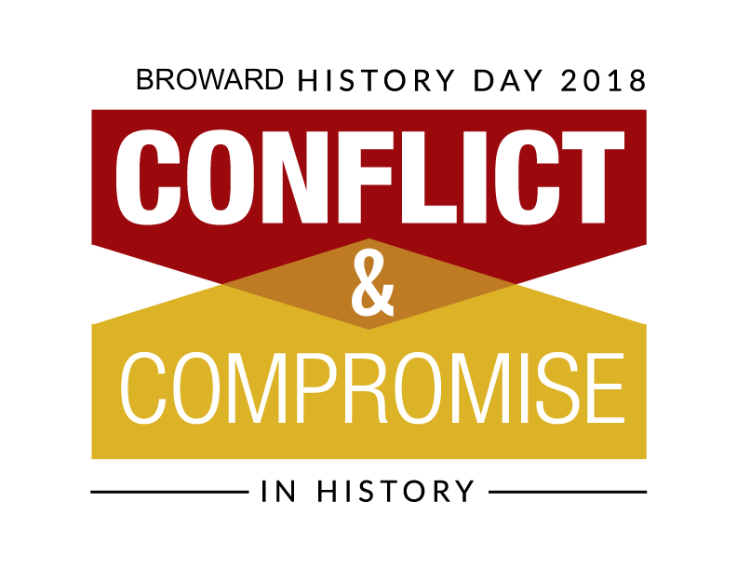

Individual Contract

Name: __________________________________________________________________

General topic: ___________________________________________________________

Area of emphasis: ________________________________________________________

Date project is due: _______________________________________________________

I will complete an individual entry for Broward County History Day. I understand that along with the freedom and independence of an individual entry, I will have to complete all aspects of it on my own without help from other students or adults. I have reviewed the rules and regulations with my parents/guardians and understand all the requirements of the event.

Student signature: ________________________________________________________

I have received the Broward County History Day rules and regulations and have reviewed them with my son/daughter. He/she has my permission to enter the competition.

Parent/guardian: _________________________________________________________

Teacher signature: ________________________________________________________

Date: __________________________________________________________________

