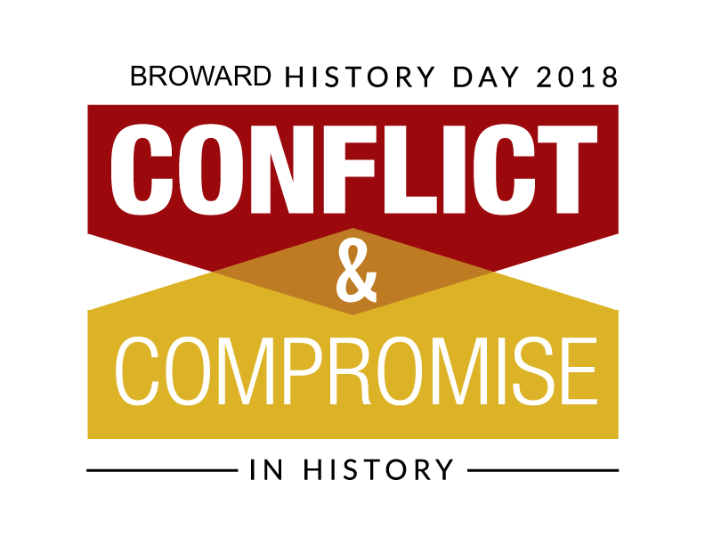

Parents' Role
Some points to remember when working on a project with your child:

1. Give encouragement, support and guidance.
2. Make sure your child feels it is his or her project. Make sure the work is the work of the child.
3. Realize the main goal of a National History Day project is to help your child use and strengthen the skills they have learned and developed. The main goal should not be a contest, medal or prize.
4. Assist your child or children as they conduct research. Adults can help students locate materials, but students should take notes, conduct interviews, etc.
5. Make sure your child is doing a project they are interested in or excited about.
6. Help your child plan a mutually agreed upon timeline to prevent a last-minute project. Talk with your child's teacher to find out the timetable for completing an NHD project. We suggest allowing 12 weeks from start to finish.
7. Provide transportation for research trips to libraries, museums, universities, etc.
8. Work with your child to evaluate the content on web sites visited for research. Make sure the site is a reliable source of information. Encourage your child to explore resources beyond the Internet. Only a fraction of available primary source documents can be found online.
9. Learn about your community with your child. Find out what kinds of museums and historical sites are in your area. Your child may even want to do a project on your family history. Get involved in your child’s learning process and share this experience.
10. Help at your local school or district NHD contests. Contact your child’s teacher or your NHD district coordinator to volunteer.

Finishing an NHD project is a huge accomplishment. Let your child know how proud you are.

