

BROWARD COUNTY HISTORY DAY

2019

RULE BOOK



Nora Rupert, Chair
Heather P. Brinkworth, Vice Chair

Robin Bartleman
Abby M. Freedman
Patricia Good
Donna P. Korn
Laurie Rich Levinson
Ann Murray

Dr. Rosalind Osgood

Robert W. Runcie
Superintendent of Schools

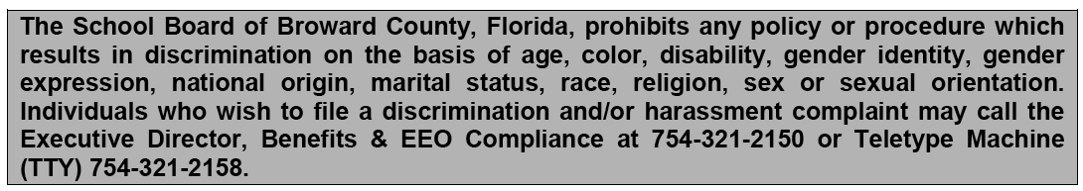

www.browardschools.com
TABLE OF CONTENTS

- PROGRAM OVERVIEW
A. Definitions 4
B. Themes 6
C. Topics 6
D. Divisions 6
E. Contest Categories 7
F. Coordinator Responsibilities 7

II. RULES FOR ALL CATEGORIES
A. General Rules for all Categories 9
B. Required Written Materials for all Entries 10
C. Contest Participation 12
D. Rule Changes (2015) 13

- INDIVIDUAL CATEGORY RULES
A. Papers 16
B. Exhibits 17
C. Performance 18
D. Documentary 20
E. Website 22

III. HOW WILL YOUR ENTRY BE JUDGED?
A. Benefits of the Evaluation Process 24
B. Who are the Judges? 24
C. The Subjective Nature of Judging 24
D. The Decision of the Judges if Final 24
E. Evaluation Criteria 25
F. Rule Compliance 25
G. Sample Judge’s Evaluation 25

IV. CATEGORY CHECKLIST
Exhibit Category 26
Performance Category 26
Documentary Category 26
Historical Paper Category 27
Web-Site Category 27
Sample Topics 28

V. MISCELLANEOUS
Intent to Participate Form 30
Summary of School Entries 31
Participation in the State History Day 32
Sample Judging Forms 33

VI. EMERGENCY CONTACT FORM 38

BROWARD COUNTY HISTORY DAY

CONTEST RULES AND GUIDELINES
(Adapted from the National History Day Contest Rule Book)

WHAT IS BROWARD COUNTY HISTORY DAY?

The Broward County History Day is a program that allows students to research a world, national, state, or local history topic. The program allows students to express what they have learned through creative and original performances, web sites, documentaries, papers, and three-dimensional exhibits.

The local county History Day mirrors the Florida History Day and the National History Day Competition. Winners from the County History Day can progress on to the Florida History Day held in Tallahassee every May and winners from the Florida History Day can progress on to the National Day held in Maryland every June.

Resources about the County Day can be found at:
http://browardcountyhistoryday.weebly.com/
Resources about the State Day can be found at:
www.floridahistoryday.com
Resources and information about the National History Day Competition can be found at
www.nhd.org.

Please note: All students must follow The Broward County Code of Student Conduct and it overrides all State and National Competition Rules.

Please Read This!

Before you begin work on your entry, you, your teacher, and your parents should carefully read this booklet. This guidebook contains rules that you must follow to compete in the Broward County History Day.

Definitions

Historical Context: The intellectual, physical, social, and cultural setting in which events take place.

Historical Perspective: Understanding a topic’s development over time and its influence in history.

Plagiarism: Plagiarism is using the work or ideas of others in ways that give the impression that these are your own (e.g. copying information word-for-word without using quotations and footnotes, paraphrasing an author’s ideas, or using visuals or music without giving proper credit).

Primary Sources: The most basic definition of a primary source is that which is written or produced in the time period students are investigating. Primary sources are materials directly related to a topic by time or participation. These materials include letters, speeches, diaries, newspaper articles from the time, oral history interviews, documents, photographs, artifacts, or anything else that provides first-hand accounts about a person or event. This definition also applies to primary sources found on the Internet. A letter written by President Lincoln in 1862 is a primary source for a student researching the Civil War era. A newspaper article about the Battle of Gettysburg written by a contemporary in July 1863 would be a primary source; but an article about the battle written in June 2001 probably was not written by an eyewitness or participant and would not be a primary source. The memories of a person who took part in the battle also can serve as a primary source. He or she was an eyewitness to and a participant in this historical event at the time. However, an interview with an expert (a professor of Civil War history, for example) is not a primary source UNLESS that expert actually lived through and has first-hand knowledge of the events being described (highly unlikely for a Civil War historian).

Note: Primary materials, such as quotes from historical figures and photographs of historical events, can be found in secondary sources and used effectively in History Day projects. However, these are not considered primary sources. Check out the “Research Roadmap” on the NHD Web site at www.nhd.org for additional help on primary sources.

Secondary Sources: Secondary sources are usually published books or articles by authors who were not eyewitnesses or participants in the historical event or period and who base their interpretation on primary sources, research, and study. These sources provide context for a historical event. For example, high school history textbooks and other history books about a particular topic are secondary sources. Biographies, newspaper retrospectives, and reference books such as encyclopedia are also secondary sources. This definition also applies to secondary sources found on the Internet.

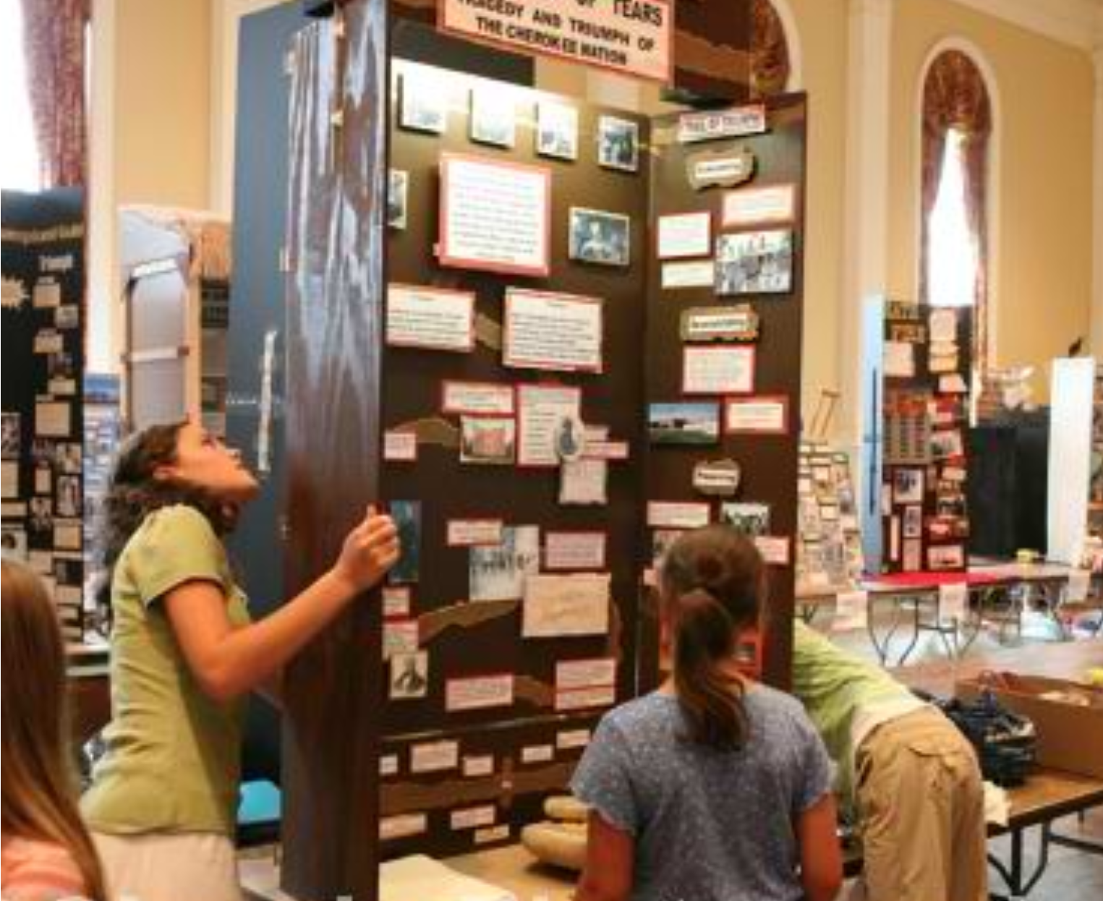

PROGRAM OVERVIEW

- THEMES

Each year a broad theme is selected for the National History Day contest. The Broward County History Day follows this theme. You may select a topic on any aspect of local, regional, national, or world history. Regardless of the topic chosen, your presentation of your research and conclusions must clearly relate to the annual theme. Be careful to limit the scope of your topic to make the research and interpretation of your topic manageable. In other words, narrow your topic to focus on an issue that can be explained and interpreted within the category limits of size and time.

- TOPICS*

Entries not only describe an event or a development, they also analyze it and place it in its historical context. Ask yourself the following questions about your topic:
- How is my topic important?
- How was my topic significant in history in relation to the National History Day theme?
- How did my topic develop over time?
- How did my topic influence history?
- How did the events and atmosphere (social, economic, political, and cultural aspects) of my topic’s time period influence my topic in history?

NOTE: You should ask questions about the topic’s development over time and its impact in history. Your answers to such questions will help you draw conclusions about your topic’s significance in history.

* NHD highly recommends that you encourage your student(s) to select a topic that began at least 25 years ago. The expectation is that the entry will analyze historical significance, which is difficult to do when a topic is too recent. Keep in mind that the judges will be aware of this recommendation.

- DIVISIONS

The District History Day Competition has two divisions based on school grade:
  - Junior Division – grades 6, 7, and 8.
  - Senior Division – grades 9, 10, 11, and 12.

Entries in each division are judged separately at all levels of competition.

NOTE: Students in non-graded schools must check with the National History Day office to determine in which division they should register for the competition.

D. CONTEST CATEGORIES

You may enter one of seven categories:
- paper (individual only)
- individual exhibit
- group exhibit
- individual performance
- group performance
- individual documentary
- group documentary
- individual web site
- group web site

Each category in each division is judged separately. Groups may include 2 to 5 students. Group participants do not have to be in the same grade to compete together, but they must be in the same division.

NOTE: Choose a category in which you can make the best use of your own special abilities, talents, and interests. Be careful to choose the most suitable category in which to present your research and conclusions and take into consideration the availability of equipment and resources.

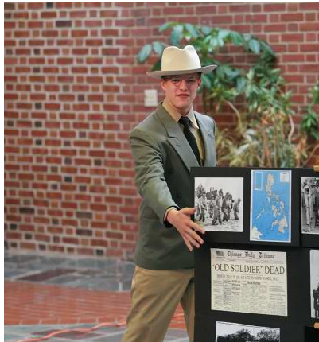

School Day Competitions Coordinator Responsibilities

- Copy and distribute the rules and requirements and other History Day information promptly.

- Attend all coordinator meetings or workshops or arrange for alternate coverage if
unable to attend.

- Develop a timeline of tasks that need to be completed to plan for the school Day.
(Example: ordering and copying materials, securing dates and location for Day, training new teachers, securing and preparing proper clearance paperwork for judges, sending letters to parents, contracts for students).

- Coordinate school Day.

- Assure proper signatures and dates on paperwork. For example, teachers must not sign responsibility or entry forms in lieu of parent’s signature. Teachers sign only where designated for teachers’ signature.

- Assure that names and titles of projects of school-based winners (1st place winners only) are submitted to the District Day Coordinators by the required due date of January 18, 2019. Names submitted after this date will not be accepted. Participant registration form and a summary form of school entries will be provided for all school-based coordinators. The entry forms must be filled out on google docs by January 18, 2019.

- For students who win at the District Day and progress on to Florida History Day, provide information on the State History Day information sheet. Assistance for planning and coordinating a school History Day is available through the District Social Studies Office. Please contact Louise Ball at (754) 321-1870.

RULES FOR ALL CATEGORIES

NOTE: These have been changes to some rules. Please read the Summary of Rules Changes at the end of this section.

A. General Rules for All Categories

Rule 1: Annual Theme
Your entry must be clearly related to the annual theme and explain your topic’s significance in history.

Rule 2: Contest Participation
You may participate in the research, preparation, and presentation of only one entry each year.

NOTE: Do not share research with other students unless you are members of the same group and creating one entry together. It is not acceptable to have a common pool of research from which several entries are created.

Rule 3: Individual or Group Entries
A paper, individual exhibit, individual documentary, individual performance or individual web site must be the work of only one student. A group exhibit, group performance, group web site or group documentary must be the work of 2 to 5 students. All students in a group entry must be involved in the research, interpretation, and creation of the group’s entry.

Rule 4: Development Requirements
Entries submitted for competition must be researched and developed during the current contest year that begins following the national contest each June. Revising or reusing an entry from a previous year –whether your own or another student’s-is unacceptable and will result in disqualification.

Rule 5: Construction of Entry
You are responsible for the research, design, and creation of your entry. You may receive help and advice from teachers and parents on the mechanical aspects of creating your entry:
- You may have help typing your paper and other written materials.
- You may seek guidance from your teachers as you research and analyze your material, but your conclusions must be your own.
- You may have photographs and slides commercially developed.
- You may have reasonable help cutting out your exhibit backboard or performance props (e.g., a parent uses a cutting tool to cut the board that you designed).

Note: Objects created by others specifically for use in your entry violate this rule. For example, a parent takes photographs or an artist draws the backdrop for your exhibit or performance. You may receive reasonable help in carrying and placing props and exhibits.

Rule 6: Contest Day Set-up
You are responsible for setting up your own exhibits, equipment or props at the contest. You may have reasonable help carrying them, but set-up must be completed by you (and your group members if applicable) only.

Rule 7: Supplying Equipment
You are responsible for supplying all props and equipment at each level of competition. All entries should be constructed keeping transportation, set-up time, size and weight in mind (e.g., foam core v. solid oak exhibit or folding table v. antique desk for a performance). Projection screens for documentaries and performances may be provided if requested but are not guaranteed. DVD players for the Documentary category will be available. Students may provide their own computers and software if they prefer. Pianos and Internet access are not guaranteed except in website judging locations.

Note: Be prepared; bring extensions cords if needed and check with your contest coordinators about the availability of special equipment.

Rule 8: Discussion with Judges
Be prepared to answer judges’ questions about the content and development of your entry, but you may not give a formal, prepared introduction, narration or conclusion. Let the judges’ questions guide the interview. Ultimately, your entry should be able to stand on its own without any additional comments from you.

Note: You should be prepared to explain the design, research, and creation of your entry if questioned by the judges. Judges need to know that your entry is the result of your own work.

Rule 9: Costumes
You are not permitted to wear costumes that are related to the focus of your entry during judging, except in the performance category. It is strongly advised that students not wear any clothing with the name of their school on it. It is requested that students come dressed appropriately for the interview.

Rule 10: Prohibited Materials
Items potentially dangerous in any way (original form or replica)—such as weapons, firearms, barbed wire, animals, organisms, plants, etc.—are strictly prohibited. Please see the Broward County Student Code of Conduct Book. Please contact your teacher and contest coordinator to confirm guidelines before bringing the replica to a contest.

Rule 11: Title

Your entry must have a title that is clearly visible on all written materials.

B. Required Written Materials for all Entries

Rule 12: Written Materials
Entries in all categories except historical papers must include four copies of the following written materials in the following order:
- A title page as described in Rule 13.

- A process paper as described in Rule 14 (process papers are not needed for historical paper entries)
- An annotated bibliography as described in Rule 15. These materials must be typed or neatly printed on plain white paper and stapled together in the top left corner. Do not enclose them in a cover or binder.

Rule 13: Title Page
A title page is required as the first page of written material in every category. Your title page must include only the title of your entry, your name(s) and the contest division and category in which you are entered. For participation in the County Day,
schools will be assigned an entry number which must be listed
on all written information.

TITLE

STUDENT(S) NAME(S)
DIVISION
CATEGORY

Note: The title page must not include any other
information (pictures, graphics, borders, school
name, or grade) except for that described in
this rule.

(e.g. Individual/Group, Exhibit, Documentary, Performance, Web Site)

Rule 14: Process Paper
A process paper is a description of no more than 500 words explaining how you conducted your research and created and developed your entry. All categories except historical papers must include a process paper with their entry. Websites should include the process paper on the site as well. The process paper should address the following four sections: (1) how you chose your topic, (2) how you conducted your research, (3) how you selected your presentation category and created your project and (4) how your project relates to the annual theme. A sample process paper can be found at the end of this booklet. Indicate the word count.

Rule 15: Annotated Bibliography
An annotated bibliography is required for all categories. Websites should include the annotated bibliography on the site. It should contain all sources that provided usable information or new perspectives in preparing your entry. You will look at many more sources than you actually use. You should list only those sources that directly contributed to the development of your entry. Sources of visual materials and oral interviews must be included. The annotations for each source must explain how you used the source and how it helped you understand your topic. Annotations of web sites should include a description of who sponsors the site. For example:

Bates. Daisy. The Long Shadow of Little Rock, New York; David McKay Co., Inc., 1962.

Daisy Bates was the president of the Arkansas NAACP and the one who met and listened to the students each day. This first-hand account was very important to my paper because it made me more aware of the feelings of the people it involved.

NOTE: Oral history transcripts, correspondence between you and experts, questionnaires and other primary or secondary materials used as sources for your entry should be cited in your bibliography but not included as attachments to your bibliography.

Rule 16: The Separation of Primary and Secondary Sources
You are required to separate your bibliography into primary and secondary sources (list primary sources first).

NOTE: Some sources may be considered as either primary or secondary. Use your annotations to explain your reasoning for classifying any sources that are not clearly primary or secondary. Listing a source under both primary and secondary is inappropriate.

Rule 17: Style Guides
Style for citations and bibliographic references must follow the principles in one of the following style guides:

- Kate L. Turabian, A Manual for Writers of Term Papers, Theses, and Dissertations.

- Joseph Gibaldi, MLA Handbook for Writers of Research Papers, 5th edition.

Regardless of which manual you use, the style must be consistent throughout the paper.

Rule 18: Plagiarism
You must acknowledge in your annotated bibliography all sources used in your entry. Failure to credit sources is plagiarism and will result in disqualification. IT IS HIGHLY RECOMMENDED THAT ALL text be submitted via Canvas in BCPS schools so that VeriCite can be used. ALL projects are subject to VeriCite verification if any questions arise.

C. Contest Participation

Rule 19: Entry Procedure
At each contest level you must register and meet specific deadlines and procedures established by your contest coordinator. For the Broward County History Day the school coordinator must submit a paper entry for each project. You may submit only one entry for each category.

Rule 20: Entries to National Competition
Each state is limited to no more than two entries per contest category in the national contest. Ties at state contests will be resolved at the state level.

Rule 21: National Competition Attendance
Individual students and groups must be present for an entry to be judged at the national contest.

Rule 22: Automatic Disqualifications
Failure to submit a process paper, title page, and/or annotated bibliography will result in automatic disqualification. Failure to submit 4 copies of each of the above will result in disqualification. Plagiarism of any portion of a project will result in disqualification.

Websites should have the process paper and bibliography included on the site. All materials for the exhibits must be brought the night before with the exhibit.

Summary of Significant Changes to Contest Rule Book

August 2014
National History Day has revised the Contest Rule Book, effective with the beginning of the 2014-15 contest year. Changes to the rules impact student participation at each level of the competition. While the NHD contest is not focused solely on rules, the Contest Rule Book sets forth the foundation for the entire program and establishes a consistent and Day footing for the contest cycle, from school level to the National Contest. NHD strongly recommends that teachers review the entire Contest Rule Book, available at www.nhd.org, and share it with students. Below is a summary of the major changes. Please refer to the Contest Rule Book for exact wording, full explanations, and examples of these changes. Please also thoroughly read the expanded "Definitions" section for clear explanations of common terms. Contact your affiliate coordinator with any questions.

New Rules

Exhibit: Credits of Visual Sources Required on Exhibits
Students must include a brief credit, on the exhibit itself, for all visual sources (e.g., photographs, paintings, charts, graphs, etc.). They also must fully cite these sources in their annotated bibliography. (See: IV. Individual Category Rules – B. Exhibit, Rule B4, pages 24-25.)
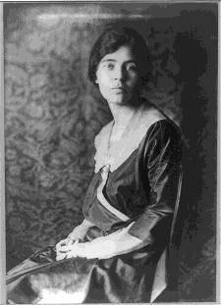

- Keep in mind that a credit will be much briefer than a full citation. For example: The credit below includes the organization where this picture can be found (Library of Congress) but does NOT include the details that are part of the bibliographic citation.
- Students may consider including these credits in a smaller font, below the image on the exhibit, similar to how a credit appears in a book. These brief credits do NOT count toward the student-composed word count.

Alice Paul, 1918, Library of Congress (A brief, factual credit is required and does not
count
toward 500 word limit)

Alice Paul was responsible for the (A student-written caption counts toward
campaign for women’s suffrage and 500-word limit)
the introduction of the Equal Rights
Amendment.

Required Documentation of Word Counts for All Categories
Students must document the word count for projects in all categories. Refer to the Contest Rule Book for category word limits as well as guidance on determining word counts in each category. (See: III. Rules for All Categories – Rule 14, page 17 and IV. Individual Category Rules – E. Website, Rule E3, page 32.)
- Paper: Total number of words in paper included on title page
- Exhibit: Number of student-composed words in exhibit and number of words in process paper included on title page
- Documentary and Performance: Number of words in process paper included on title page
- Website: Number of student-composed words in website and number of words in process paper included on website home page.

Title  Name  Junior Division  Historical Paper  Paper Length: 2,234 words | Title  Names  Junior Division  Group Exhibit  Student-composed words: 489  Process Paper: 410 words | Title  Name  Senior Division  Individual Performance  Process Paper: 425 words | Title  Name  Senior Division  Individual Documentary  Process Paper: 410 words

Website: Multimedia is Limited to No More than Four Minutes for Entire Website
A website may contain multimedia, audio, video, or both, but the grand total for all multimedia used within the website may total no more than four minutes. Clips are no longer limited to just 45 seconds each. Rather, students have a grand total of four minutes to divide up at their discretion. It is the student’s decision to divide up this overall media limit to best provide supporting evidence in their website. (See: IV. Individual Category Rules – E. Website, Rule E4, page 32.)
- Please note that any music or song that plays after a page loads is included in this total.
- A website could include many, smaller clips or include fewer, longer clips. The choice is up to the student.

Website: Quotes and Visual Sources Must Be Credited Within Website
Students must include a brief credit, in the website itself, for all VISUAL and WRITTEN sources (e.g., quotes, photographs, paintings, charts, graphs, etc.). They must also fully cite these sources in their annotated bibliography. (See: IV. Individual Category Rules – E. Website, E5, page 33.)
- Keep in mind that a credit will be much briefer than a full citation.
- These brief credits do NOT count toward the student-composed word count.

Clarifications: Reflecting frequently asked questions, NHD has clarified rules in the areas below.

Disqualification vs. Rule Infraction (See: I. What is National History Day?, Definitions – Rule Infraction and Disqualification, page 6; III. Rules for All Categories – Rules 4, 6, and 19, pages 14-19.)

A rule infraction is a violation of any of the rules stated in the Contest Rule Book. Failure to comply with the rules will count against an entry but will only result in disqualification as described below. Disqualification is removal from competition and results from any of the following violations:
1. Plagiarizing all or part of the NHD project, including failure to give proper credit.
2. Reusing, individually or as a group, a project (or research from a project) from a previous year, or entering a project in multiple contests or entry categories within a contest year.
3. Tampering with any part of the project of another student.

After Entering the Competition Cycle, Students Cannot Add or Replace Group Members
Once a group project enters the competition cycle (at either the Regional or Affiliate level, whichever is first), additional students may not be added and missing group members may not be replaced at that or subsequent competitions during that contest year. (See: III. Rules for All Categories – Rule 3, page 14.)
- Check with the contest coordinator about rules regarding contest attendance. Contest coordinators may or may not require that all group members be in attendance at a contest to be eligible to participate.
- If a group member cannot participate in the event, the student MUST remain listed as part of the group. He or she participated in the development of the entry. A project cannot move from a group entry to an individual entry once it enters the competition cycle.

Check with Contest Coordinators About Available Documentary and Performance Equipment
Students must check with their contest coordinator at EACH LEVEL OF COMPETITION about the type of equipment available at the contest venue, especially in the documentary category. Students should use care in saving the project in the correct file format and be sure to bring back-up copies. It is the student’s responsibility to make sure their documentary is playable at the competition. (See: III. Rules for All Categories – Rule 8, page 15.)

Website: Printed Copies of Process Papers and Bibliographies are Not Required for Websites
The website category requires that all written materials (process paper and annotated bibliography) are included in the website itself. Students are not required to submit printed copies of these materials when registering for any level of an NHD contest. (See: IV. Individual Category Rules – E. Website, E9, page 33.)

INDIVIDUAL CATEGORY RULES

A. Papers

A paper is the traditional form of presenting historical research. Various types of creative writing (for example, fictional diaries, poems, etc.) are permitted, but must conform to all general and category rules. Your paper should be grammatically correct and well written.

Part II, Rules for all Categories (except for Rule 14), apply to all papers

Rule 1: Length Requirements
The text of historical papers must be no less than 1,500 and no more than 2,500 words in length. Each word or number in the text of the paper counts as one word. The paper category 2,500 word limit does not apply to: notes, annotated bibliography, illustration captions, and supplemental/appendix material. Appendix material must be directly referred to in the text of the paper. Extensive supplemental materials are inappropriate. Use of appendices should be very limited and may include photographs, maps, charts, graphs, but we strongly suggest no other supplemental materials. Please indicate the word count on the title page (see rule change above)

NOTE: Oral history transcripts, correspondence between you and experts, questionnaires, and other primary or secondary materials used as sources for your paper should be cited in your bibliography but not included as attachments to your paper.

Rule 2: Citations
Citations—footnotes, endnotes or internal documentation—are required. Citations are used to credit the sources of specific ideas as well as direct quotations. Refer to Part II, Rule 17, for citation styles. Please note that an extensively annotated footnote should not be used to get around the word limit.

Rules 3: Preparation Requirements
Papers must be typed (Times New Roman or Arial), computer printed, or legibly handwritten in ink on plain, white 8.5 x 11-inch paper with 1-inch margins on all sides. Pages must be numbered consecutively and double-spaced with writing on one side and with no more than 12 characters per inch or no less than 10-point type. Papers must be stapled in the top left corner and should not be enclosed in any cover or binder. The title page should have no illustrations.

Rule 4: Number of Copies
Four copies of the paper must be submitted, prior to the contest, with the appropriate entry form by the deadline established for the contest. Contest officials sometimes publish winning papers; you must be prepared to give permission for such publication. Students are responsible for picking up papers after the contest. See academic Handbook for exact date that Historical Papers must be submitted.

NOTE: Four copies of the annotated bibliography must be included with the student(s) paper. (Remember to put a title page in front of each copy of the historical paper).

EXHIBIT CATEGORY

- Exhibits

An exhibit is a visual representation of your research and interpretation of your topic’s significance in history, much like a small museum exhibit. The analysis and interpretation of your topic must be clear and evident to the viewer. Labels and captions should be used creatively with visual images and objects to enhance the message of your exhibit.

Part II, Rules for all Categories, applies to exhibits.

Rule 1: Size Requirements

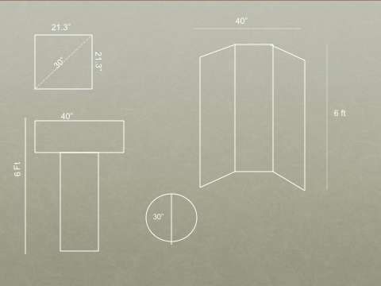

The overall size of your exhibit when displayed for judging must be no larger than 40 inches wide, 30 inches deep, and 6 feet high. Measurement of the exhibit does not include the table on which it rests; however, it would include any stand that you create and any table drapes. Circular or rotating exhibits or those meant to be viewed from all sides must be no more than 30 inches in diameter. (see diagram below)

Rule 2: Media Devices
Media devices (e.g., tape recorders, projectors, video monitors, computers) used in an exhibit must not run for more than a total of 3 minutes and are subject to the 500 word limit (rule 3). Viewers and judges must be able to control media devices. Any media devices used must fit within the size limits of the exhibit. Any media devices used should be integral to the exhibit—not just a device to bypass the prohibition against live student involvement.

NOTE: For example, a brief excerpt from a taped student-conducted oral interview or a dramatic reading might be appropriate, but taped commentary or analysis is inappropriate.

Rule 3: Word Limit
There is a 500 word-limit that applies to all text created by the student that appears on or as part of an exhibit entry. This includes the text you write for titles, subtitles, captions, graphs, timelines, media devices (e.g., video, slides, computer files) or supplemental materials (e.g., photo albums, scrapbooks, etc.) where you use your own words.

NOTE: A date counts as one word, while each word in a name is individually counted. For example, January 1, 2006 counts as one word, but John Quincy Adams counts as three.

Words such as “a,” “the” and “of” are counted as one word each.

Brief citations crediting the sources of illustrations or quotations included on the exhibit do not count toward the 500-word limit.

NOTE: Be careful that your message is clear and contained on the exhibit itself; judges have little time to review supplemental material. Extensive supplemental material is inappropriate. For example, oral history transcripts, correspondence between you and experts, questionnaires, and other primary or secondary materials used as sources for your exhibit should be cited in your bibliography but not included as attachments to your bibliography or exhibit.

Reminder: Four copies of the title page, process paper, and annotated bibliography must be included with each exhibit. When students set up their exhibit, they should put the process papers and annotated bibliographies on the table with their projects.

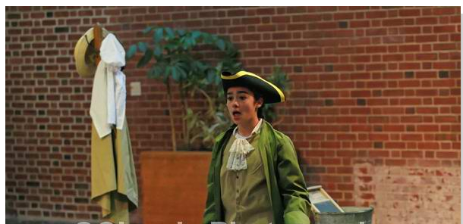

PERFORMANCE CATEGORY

- Performances

A performance is a dramatic portrayal of your topic’s significance in history and must be original in production.

Part II, Rules for all Categories, applies to performances.

Rule 1: Time Requirements
Performances may not exceed 10 minutes in length. Timing starts at the beginning of the performance following the announcement of the title and student name(s). Any other introductory remarks will be considered part of the performance and will be counted as part of the overall time. You will be allowed an additional 5 minutes to set up and 5 minutes to remove any props needed for your performance.

NOTE: You should allow several empty seconds in your performance to account for unplanned pauses (e.g. applause, forgotten lines, etc.).

Rule 2: Performance Introduction
The title of your entry and the names of the participants must be the first and only announcements prior to the start of the performance.

Rule 3: Media Devices
Use of slides, tape recorders, computers, or other media within your performance is permitted. Students must run all equipment and carry out any special lighting or sound effects.

Rule 4: Script
The script for the performance should not be included with the written material presented to the judges.

Rule 5: Costumes
You may have a costume produced for you, but the design, choice of fabrics, etc. must be your own. Or, you may rent a costume. Remember; simple is best.

Reminder: Four copies of your title page, process paper, and annotated bibliography must be part of your project. Students should hand these papers to the judges just before their performance.

DOCUMENTARY CATEGORY

- Documentaries

A documentary should reflect your ability to use audiovisual equipment to communicate your topic’s significance, just as professional documentaries do. The documentary category will help you develop skills in using photographs, film, video, audiotapes, computers, and graphic presentations. Your presentation should include primary materials but must also be an original production. To produce a documentary you must have access to equipment and be able to operate it.

Part II, Rules for all Categories, applies to documentaries

Rule 1: Time Requirements
Documentaries may not exceed 10 minutes in length. You will be allowed an additional 5 minutes to set up and 5 minutes to remove equipment. Timing will begin when the first visual image of the presentation appears and/or the first sound is heard. Color bars and other visual leads in a video will be counted in the time limit. Timing will end when the last visual image or sound of the presentation concludes (this includes credits).

NOTE: Use your set-up time to focus slides, adjust volume, etc.

Rule 2: Introduction
You must announce only the title of your presentation and names of participants. Live narration or comments prior to or during the presentation are prohibited.

Rule 3: Student Involvement

Students are responsible for running all equipment.

Rule 4: Student Production
All entries must be student-produced. You must operate all equipment. You must provide the narration, voice-overs and dramatization. Only those students listed as entrants may participate in the production or appear on camera.

Note: This does not include interviews of participants in a historical event or of experts.

Rule 5: Entry Production
Your entry must be an original production. You may use professional photographs, film, slides, recorded music, etc. within your presentation. However, you must integrate such items into your presentation and give proper credit within the presentation as well as in your annotated bibliography. You must operate all editing equipment used in the production of your presentation. *Follow Broward County School copyright rules.

Note: Using material created by others specifically for use in your entry violates this rule, except that which already exists.

Rule 6: Credits
At the conclusion of the documentary, you should provide a general list of acknowledgments and credits for all sources. These credits should be a brief list and not full bibliographic citations. All sources (music, images, film/media clips, interviews, books, web sites) used in the making of the documentary should be properly cited in the annotated bibliography.

Rule 7: Displays

Stand-alone displays are prohibited.

Rule 8: Computer Entries
You must be able to run the program within the 10-minute time limit. Interactive computer programs and web pages in which the audience or judges are asked to participate are not acceptable; judges are not permitted to operate any equipment during the initial presentation. Students must provide a DVD of their documentary for the purpose of the final elimination round. This DVD will not be returned. Judges must be able to run the program without the student during the final elimination. Students must provide and be able to run their own computers and software. Internet access will not be available. Documentaries pose the least technical problems when saved as Quick Time movie files.

Reminder: four copies of the title page, process paper and annotated bibliography must be included with the documentary. Students should hand these papers to the judges just prior to making their presentation.
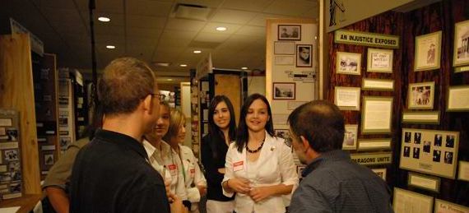

WEB SITE CATEGORY

Rule 1: Size Requirements

Web-site entries may contain no more than 1,200 visible, student-composed words.

Code used to build the site, and alternate text tags on images do not count toward the word limit. The word limit does not include words found in materials used for illustration such as documents, artifacts, or graphs not created by the student, or quotations from primary sources such as oral history interviews, letters or diaries, photos of artifacts with writing, or other illustrative materials such as recurring menus, titles and navigation instructions that are used as an integral part of the web site. Brief text crediting the sources of illustrations or quotations included on the web site do count toward the 1,200-word limit. The entire site, including all multimedia, may use up to 100MB of file space.

Rule 2: Navigation
One page of the web site must serve as the “home page”. The home page must include the names of participants, entry title, division, and a main menu that directs viewers to the various sections of the site. All pages must be interconnected with hypertext links. Automatic redirects are not permitted.

Rule 3: Multimedia
A website may contain multimedia, audio, video, or both, but the grand total for all multimedia used within the website may total no more than four minutes. Clips are no longer limited to just 45 seconds each. Rather, students have a grand total of four minutes to divide up at their discretion. It is the student’s decision to divide up this overall media limit to best provide supporting evidence in their website. (See: IV. Individual Category Rules – E. Website, Rule E4, page 32.)
- Please note that any music or song that plays after a page loads is included in this total.
- A website could include many, smaller clips or include fewer, longer clips. The choice is up to the student.
Voiceover of material not composed by students is allowed. If an entry uses any form of multimedia requiring a plug-in (for example, Flash, QuickTime or Real Player), you must provide, on the same page, a link to an Internet site where the plug-in is available as a free, secure, and legal download. Judges will make every effort to view all multimedia content, but files that cannot be viewed cannot be evaluated as part of the entry.

Rule 4: Entry Production
All entries must be original productions and created using www.nhd.weebly.com only which can be accessed through the National History Day website. School coordinators will be notified when the portal is open. You may use professional photographs, graphics, video, recorded music, etc. within the site. Such items must be integrated into the web site, and proper credit must be given within the site as well as in the annotated bibliography. No part of the web site may link to live or external sites unless the site provides a necessary plug-in. The student must operate all software and equipment in the development of the web site.

Note: Using objects created by others specifically for use in your entry violates this rule. However, using graphics, multimedia clips, etc., which already exist, is acceptable.

*Copyright rules for Broward County Public School must be followed.

Rule 5: Bibliographic Sources
The annotated bibliography must be included as an integrated part of the web site. It should be included in the navigational structure and does NOT count toward the 1,200-word limit. Refer to Part II Rules 15-17, for citation and style information.

Students must include a brief credit, in the website itself, for all VISUAL and WRITTEN sources (e.g., quotes, photographs, paintings, charts, graphs, etc.). They must also fully cite these sources in their annotated bibliography. (See: IV. Individual Category Rules – E. Website, E5, page 33.)
- Keep in mind that a credit will be much briefer than a full citation.
- These brief credits do NOT count toward the student-composed word count.

Rule 6: Stable Content
The content and appearance of a page cannot change when the page is refreshed in the browser. Random text or image generators are not allowed.

Rule 7: Viewing Files
Students are responsible for ensuring that the entry is viewable in Weebly. Entries may not link to live or external sites, except to direct viewers to plug-ins.

Rule 8: File Safety
Entries that contain potentially harmful file contamination (e.g. a virus) are subject to disqualification.

Rule 9: Submitting Entry for Judging
The URL for the website must be submitted to Nicole Marsala (nicole.marsala@browardschools.com) in advance by the established deadline. The student will bring four copies of a process paper and annotated bibliography the day of the Day just in case they are not visible on the web site at the time of judging.

See Academic Handbook for exact dates.

HOW WILL YOUR ENTRY BE JUDGED?

A. Benefits of the Evaluation Process

The goal of the History Day is to provide you with a high-quality, educational experience-whether or not you win. The judges’ evaluations is part of the learning and skill building process. The judges’ evaluations help you to improve areas or skills and provide positive feedback for the hard work you have put into producing your project. The judges’ comments also can provide you with ideas for revisions and enhancements as you move from one contest level to the next. Remember, regardless of how your entry is ranked, by participating in the History Day you will benefit from the experience. You will gain research, thinking, and presentation skills which will last your whole life. You will become an expert on a topic of interest to you and to others. You will acquire poise and self-confidence and will learn to manage your time. You are a winner.

B. Who are the Judges?

Historians, educators, and others interested in history and education serve as judges at each level of the History Day competition.

C. The Subjective Nature of Judging

Remember; judges must evaluate certain aspects of your entry that are objective (e.g., were primary sources used; is the written material grammatical and correctly spelled). But judges must also evaluate interpretive aspects of your entry which are qualitative in nature (e.g., analysis and conclusions about the historical data).

Historians often reach different opinions about the significance of the same data. It is therefore crucial for you to base your interpretations and conclusions on solid research. Judges will check to determine whether you used available primary sources and if you were careful to examine all sides of an issue and present a balanced account of your research and presentation. Your process paper and annotated bibliography are critical to this process.

D. The Decision of the Judges is Final

You, your parents, and your teachers should realize that inadvertent inequities may occur in judging and that contest officials do want to be informed of any problems. The decisions of the judges are final.

E. Evaluation Criteria

Historical Quality (60%)
The most important aspect of your entry is its historical quality. You should ask yourself the following questions to help you focus on your historical analysis:
- Is my entry historically accurate?
- Does my entry provide analysis and interpretation of the historical data rather than just a description?
- Does my entry demonstrate an understanding of historical context?
- Does my annotated bibliography demonstrate wide research?
- Does my entry demonstrate a balanced presentation of materials?
- Does my entry demonstrate use of available primary sources?

Relation to Theme (20%)
Your entry must clearly explain the relation of your topic to the annual National History Day theme. You should ask yourself the following questions to help focus your topic on the theme and its significance.
- How does my topic relate to the theme?
- Why is my topic important?
- How is my topic significant in history and in relation to the National History Day theme?
- How did my topic influence history?
- How did the events and atmosphere (social, economics, political, and cultural aspects) of my topic’s time period influence my topic in history?

Clarity of Presentation (20%)
Although historical quality is most important, your entry must be presented in an effective manner. You should ask yourself the following questions to help you focus on your presentation:
- Is my entry original, creative, and imaginative in subject and presentation?
- Is my written material clear, grammatically correct and accurately spelled?
- Is my entry well-organized?
- Do I display stage presence in a performance?
- Is the visual material I present clear?
- Do I understand and properly use all of my equipment?

F. Rule Compliance

Judges will take into consideration in their final rankings any rule infraction. Failure to comply with the rules will count against your entry. Rule infractions should be corrected before a winning entry competes in the next level of competition.

G. Sample Judge’s Evaluation

See Sample Project Evaluation Forms at the end of this book. Teachers or fellow students can use this form to help evaluate your project as you work to improve your entry. Blank forms can be found on the NHD Website at www.nhd.org.

CATEGORY CHECKLIST

Exhibit Category

Individual and Group (2-5 students)
- No larger than 40 inches wide, 30 inches deep, and 6 feet high when displayed
- Four copies of written materials: title page with required information and process paper
- Annotated bibliography, separated into primary and secondary sources (4 copies)
- Exhibit addresses the theme
- Title is clear and visible
- Labels, captions, and titles include no more than 500 words
- Has visual impact and shows interpretation
- Entry registered by deadline
- Prepared to answer judges’ questions at the contest (remember that formal narratives are not appropriate responses to questions)

Performance Category

Individual and Group (2-5 students)
- 10-minute maximum for performance
- Maximum 5 minutes to set up and 5 minutes to take down props
- Four copies of written materials: title page with required information and process paper
- Annotated bibliography, separated into primary and secondary sources (4 copies)
- Performance addresses the theme
- All props and equipment are student supplied
- Only student entrants run equipment and are involved in the performance
- Extra supplies and materials in case of emergency
- Entry registered by deadline
- Prepared to answer judges’ questions at the contest (remember that formal narratives are not appropriate responses to questions)

Documentary Category

Individual and Group (2-5 students)
- 10-minute maximum for presentation
- Maximum 5 minutes to set up and 5 minutes to take down
- Four copies of written materials: title page with required information and process paper
- Annotated bibliography, separated into primary and secondary sources (4 copies)
- Documentary addresses the theme
- Live student involvement limited to operating equipment and giving name and title
- Entry registered by deadline
- Extra supplies and materials in case of emergency
- Prepared to answer judges’ questions at the contest (remember that formal narratives are not appropriate responses to questions)
- Documentary has been saved as a QuickTime file

Historical Paper Category

Individual Only
- 1,500-2,500 words, excluding notes, annotated bibliography, and title page
- Title page with only the required information
- Annotated bibliography, separated into primary and secondary sources (4 copies)
- Paper addresses the theme
- Citations
- 4 copies of the paper submitted by the deadline
- Organization shows clear focus and progression
- Entry registered and papers mailed by deadline
- Prepared to answer judges’ questions at the contest (remember that formal narratives are not appropriate responses to questions)

Web site

Individual and Group (2-5 students)
- Contains no more than 1,200 visible, student composed words
- Home page includes names of participants, entry title, division, and a main menu
- All pages are interconnected with hypertext links
- Web site uses no more than 100 MB of file space
- The content is stable and does not change when the refresh button is hit
- Web-site is virus-free
- Annotated bibliography, separated into primary and secondary resources is included on the web site
- Process Paper is included on the web site
- Web site addresses the theme
- 4 copies of written material: title page with required information; 500 word process paper and annotated bibliography
- Entry registered by deadline
- Prepared to answer judges’ questions at the contest (remember that formal narratives are not appropriate responses to questions).
*Broward County Copyright rules must be followed.

**Please note: copies of papers will not be returned to students.

***You may submit only one entry per category

NOTE: IF STUDENTS DO NOT HAVE THEIR ANNOTATED BIBLIOGRAPHY AND/OR PROCESS PAPER THEY WILL BE AUTOMATICALLY DISQUALIFIED! (4 copies please)

2019 Sample Topics List

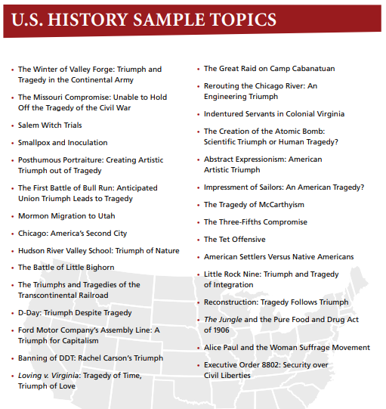

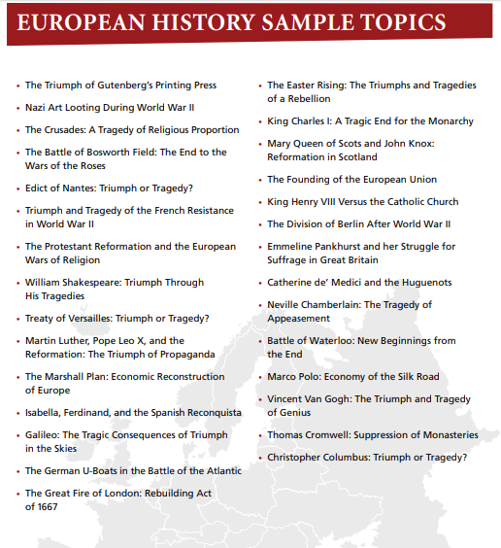

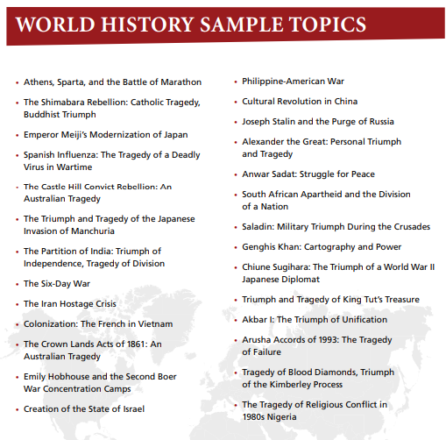

INTENT TO PARTICIPATE
2018-2019 School Year
History Day
February 22, 2019
Pompano Beach High School

School Name*: School Code #*:

School Address if charter or private school*:

Coordinator*:

Email*: __________________________________________________

Phone # at School: Home or Cell #:

Date of Your School History Day*:
(Must be before January 12th, 2018)

PRINCIPAL NAME* (SIGNATURE) PRINCIPAL NAME* (PRINT)

RETURN BY DATE: October 11, 2018
NO EXCEPTIONS!

PONY, SCAN OR MAIL TO Davien Jones, KCW, 12TH FLOOR OR
FAX TO: 754/321-1888

KC Wright
600 SE Third Avenue/13th Floor
Ft. Lauderdale, FL 33301

There is a District Competitions Fee for Private and Charter schools due by October 11, 2018. Please contact Jennifer Hamilton at jennifer.hamilton@browardschools.com for more information. Mail payment and a copy of the Intent to Participate form to:

SBBC-Pompano Administration Center
Jennifer Hamilton- Student Activities
610 NE 13th Avenue
Pompano Beach, FL 33060

*Mandatory information

School Name:

Coordinator Name:_________________________

List the student names and titles of your 1st place winners for the following project types. Submit with your entry forms to Davien Jones by Friday, January 18, 2019. *Copies of historical papers and website urls are due to the social studies office by Friday, January 18, 2019.

PROJECT TYPE | 1ST PLACE Winner
Individual Documentary
Group Documentary
Individual Performance
Group Performance
Individual Exhibit
Group Exhibit
*Historical Paper (individual only)
Individual Website
Group Website

Participation in the State History Day

Students who place first or second in the Broward County History Day have an opportunity to progress on to the State Day. An entry form must be submitted to the District Social Studies Office if a student chooses to participate in the State Day. Check with your school’s competition coordinator for the deadline date for State Day entry forms and submission of Historical Papers. Entry forms and Historical Papers should be mailed to:

Broward County Public Schools
Dr. Louise Ball, Social Studies Specialist
600 S.E. 3rd Avenue, 13th floor
Ft. Lauderdale, FL. 33301

Please call the District Social Studies Office at (754) 321-1870 to ensure that your form was received. Students, parents and schools should work together in coordinating travel to the State Day. The District Office does not provide transportation or pay for any costs associated with the State and National Competition. Students who choose not to attend the State Day after submitting their entry form, must contact the District office immediately.



Sample Project Evaluation forms
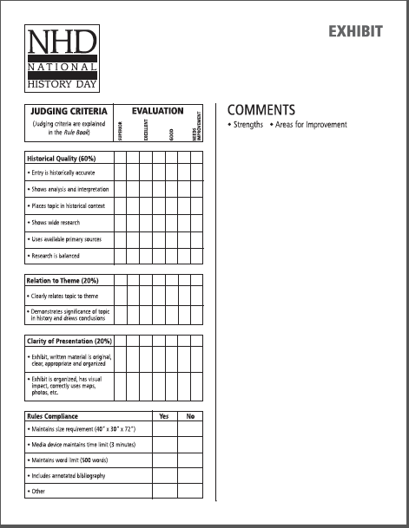
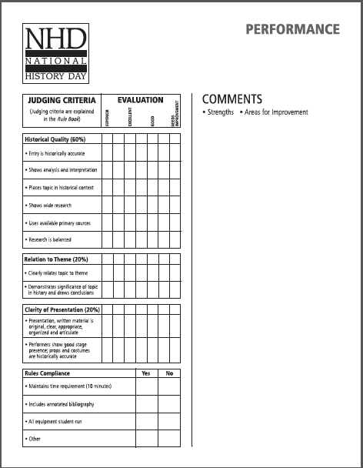
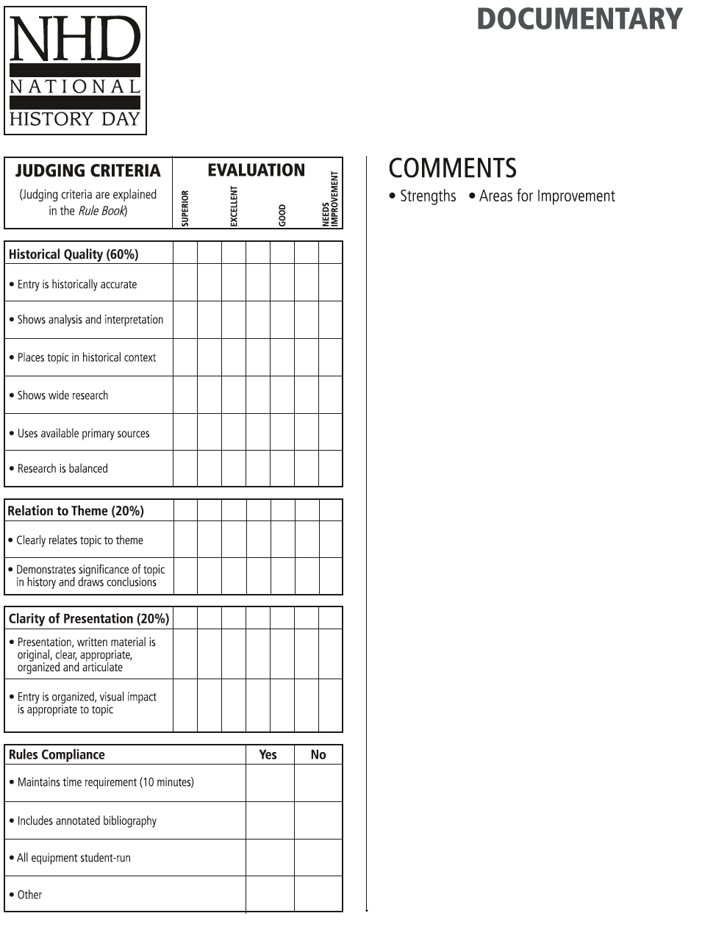
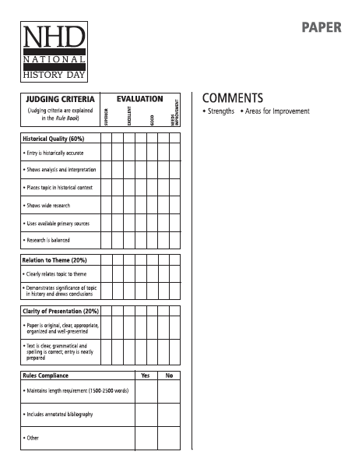
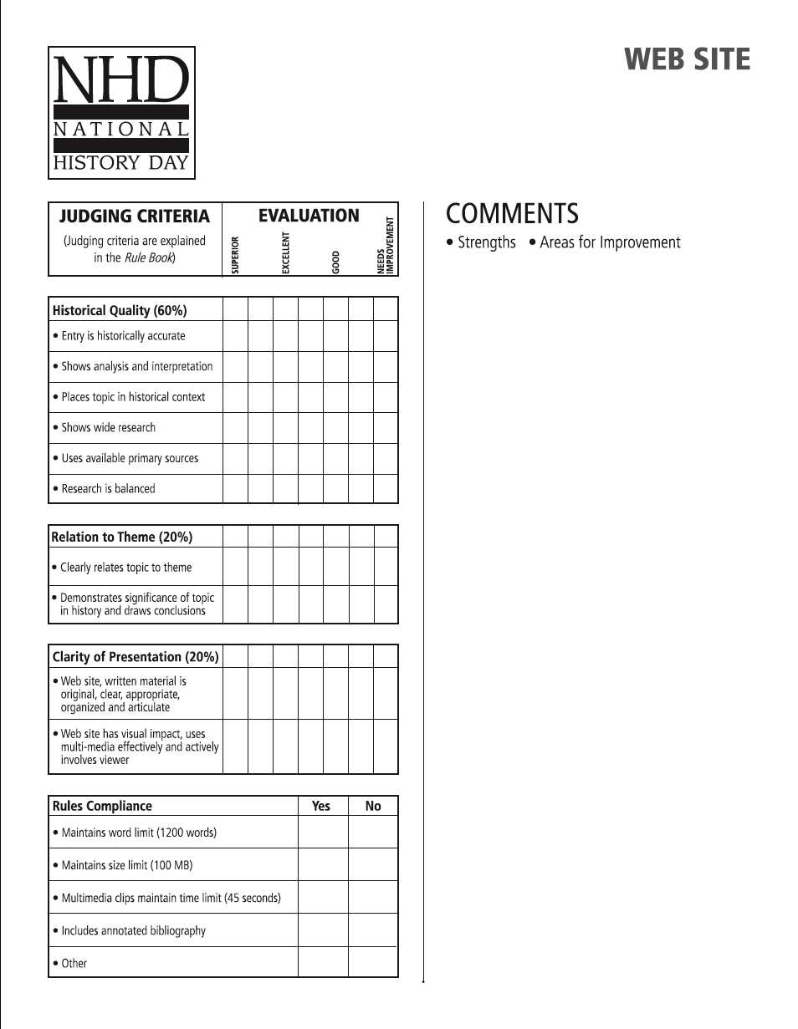

Broward County History Day
Pompano Beach High School Board of Broward County
February 22, 2019

Student Emergency Contact Form

Any student participating in the Broward County History Day must complete this Emergency Contact Form and mail it to the address listed below by February 1, 2019.

Please Print

Student Information

Last Name: _________________________ First Name: _____________________________

Grade Level: ____________________________________

School Name: ______________________________________________________________

Teacher Name: ______________________________________________________________

Home Address: ______________________________________________________________

Home Phone Number: _________________________________________________________

Parent/Guardian Name: ________________________________________________________

Work Phone Number: _____________________ Cell Phone Number:___________________

Parent/Guardian Name: ________________________________________________________

Work Phone Number: _______________________ Cell Phone Number:_________________

_____________________________________________________ __________________
Parent Signature Date

Please return this form to: Dr. Louise Ball
600 SE Third Ave. 13th Floor
Ft. Lauderdale, FL 33301

Due: February 1, 2019

38

