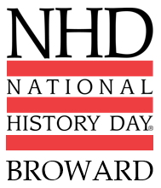
Broward History Day-Timeline
September 1, 2023 | All information will be posted History Day Website  http://browardcountyhistoryday.weebly.com/
September 1, 2023 | Intent to Participate will be emailed and accessible via Website.  Click Here to access Intent Form
October 12, 2023 | Intent to Participate is due by 5pm.  Intent must be sent by a teacher or coordinator.  Charter and Private schools, ensure that you also pay Student Activities Fee and other required forms.  Click Here to access Intent Form
January 12, 2024 | All student registration forms are due by 5pm
January 17, 2024 | All projects uploaded to the Canvas Course.  Note: Links will be sent after registration is received.
February 2, 2024 | Judges Meet & Score
February 5-6, 2024 | Winners announced!
May 5-7 2024 | Florida History Day, Interview in Person. Tallahassee, FL

Contact Information:
- Jasmine.Medina@browardschools.com
- Nicole.Marsala@browardschools.com

